THE Amazing Vincent Van Gogh

There was a man, who loved art. His name was Vincent van Gogh and he did not have a long
life but it was exciting! This poster will tell you lots of facts about van Gogh.
Van Gogh didn’t have a big education . In fact he started going to school at the age of 16. Van Gogh was born on the 30th
Of march 1853 in the Netherlands . His farther was a reverend and his mother was called Anna. He had two brothers: Theo and Cor and three sisters Will, Anna and Lies.
FAMOUS!
Van Gogh is known for his detailed art . He loved art, even in his spare time he would do art . He sent letters to Theo all about his art and he tried so hard in his work .
Why People Should Know About Van Gogh
The reason people should know about van Gogh is that he only soled 2 pieces of art in his life. He didn’t live very long because when he got older he became ill. However he was a very skilled artist.
ART
Any one can do art because art is never wrong or bad. It’s simple if you think about it carefully and learn new techniques – just like Van Gogh!
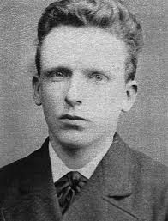

Early years

